<https://navinet.navimedix.com/sign-in?ReturnUrl=/>

user and pass - ebluea / xH{6L7s788

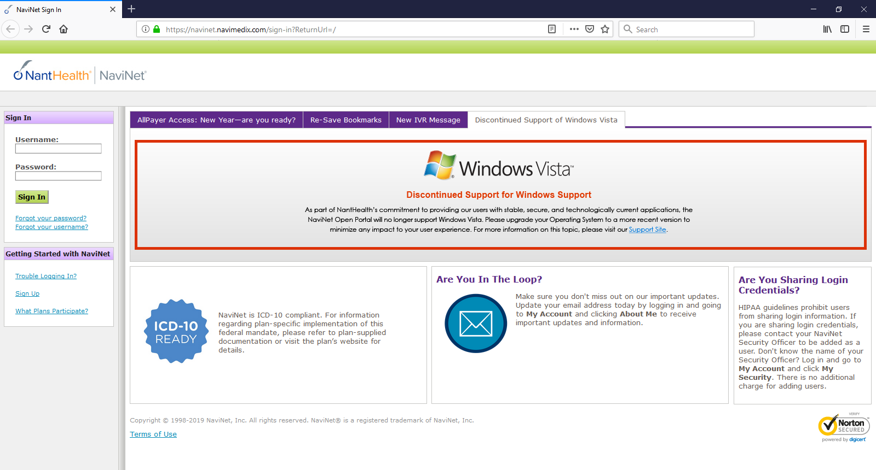

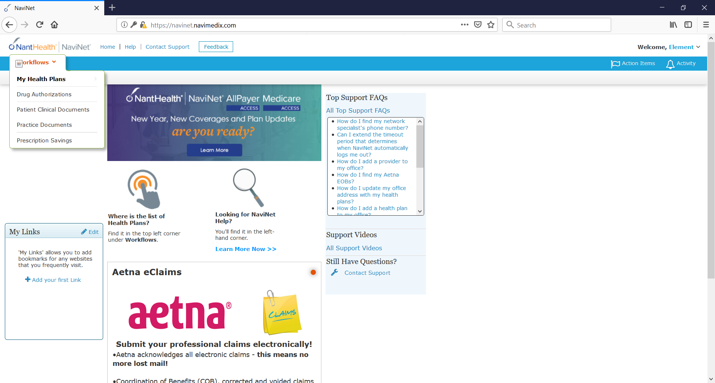

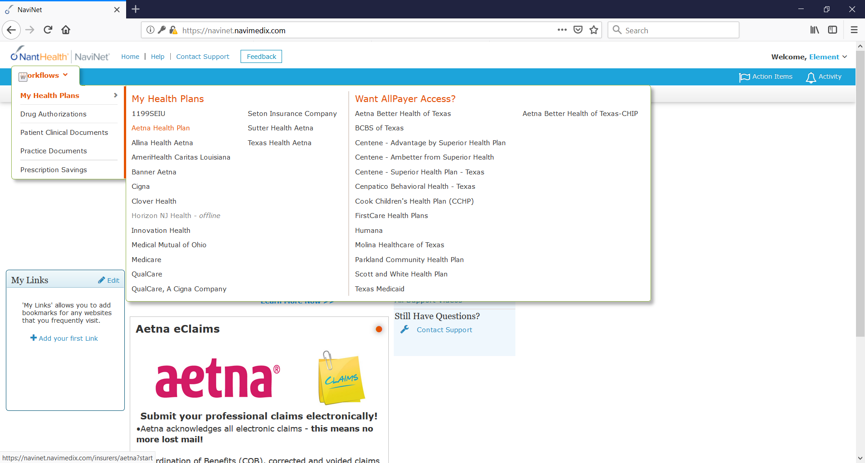

Select Aetna Health Plan

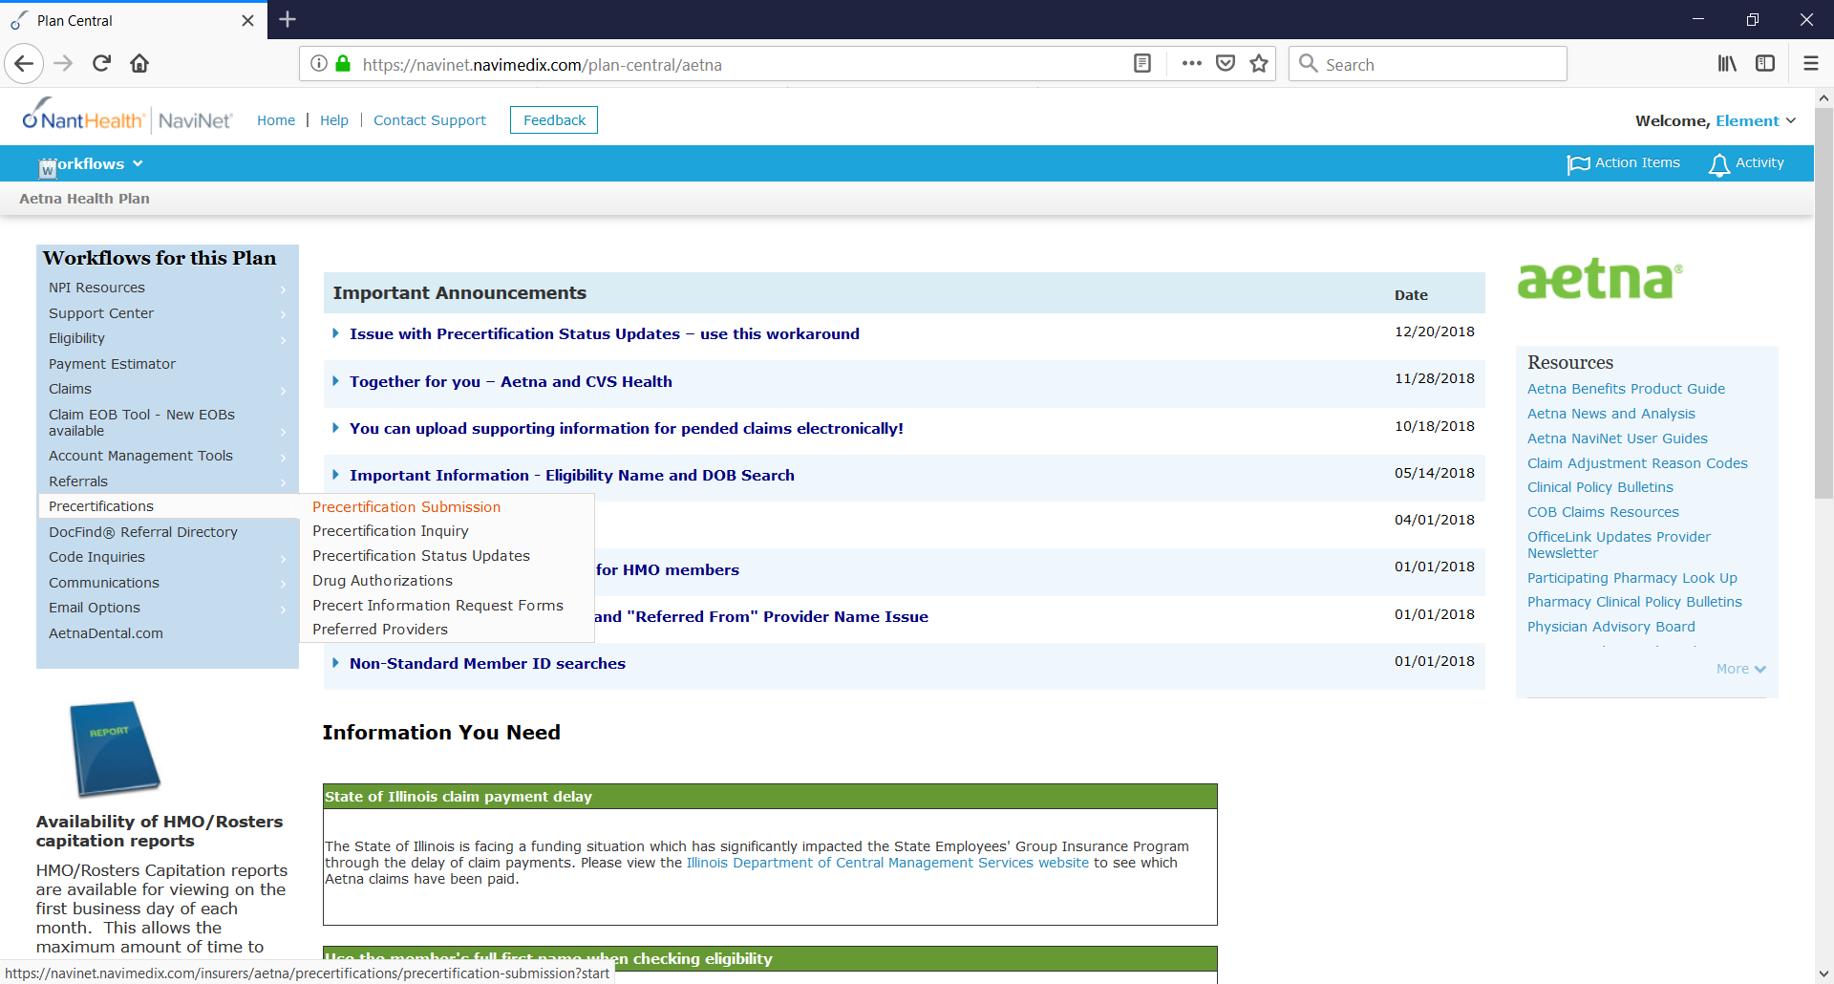

Select pre-certification submission

Enter NPI – 1730132234

Select first record from result.

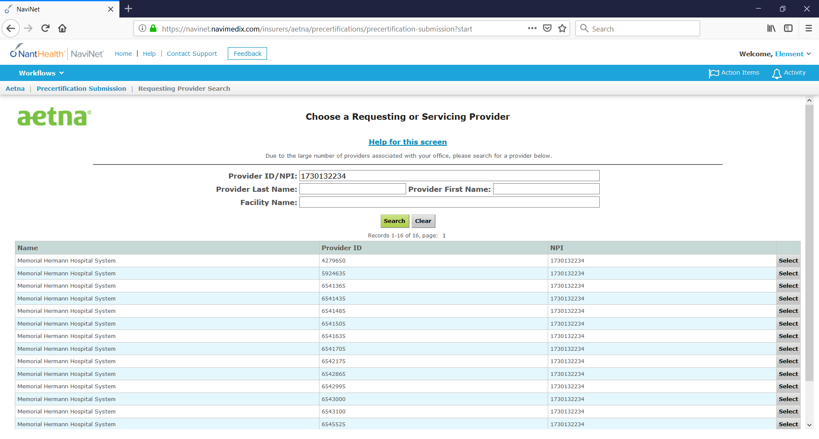

Enter member id and dob - W189719633 & 09/25/1969

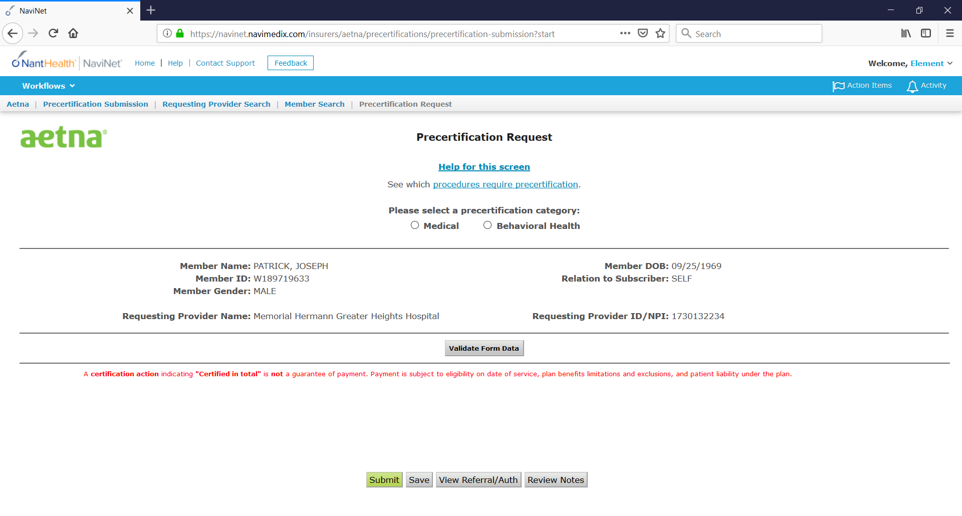

Select Medical and then Inpatient

Here we will be entering all the information from csv, I am still working with client to understand more but you can at least start working till here.